Adarsh Singh
202401100200017
CSE-A

1. GitHub repository URL: Adarsh011732/github-skills-challenge
2. Pull request URL used to validate the workflows: Trigger workflow on PR validation by Adarsh011732 · Pull Request #1 · Adarsh011732/github-skills-challenge
3. Screenshot showing the GitHub Actions workflows:
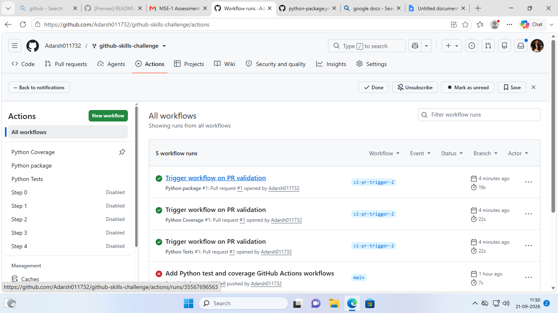
4. Screenshot showing a successful test workflow execution:
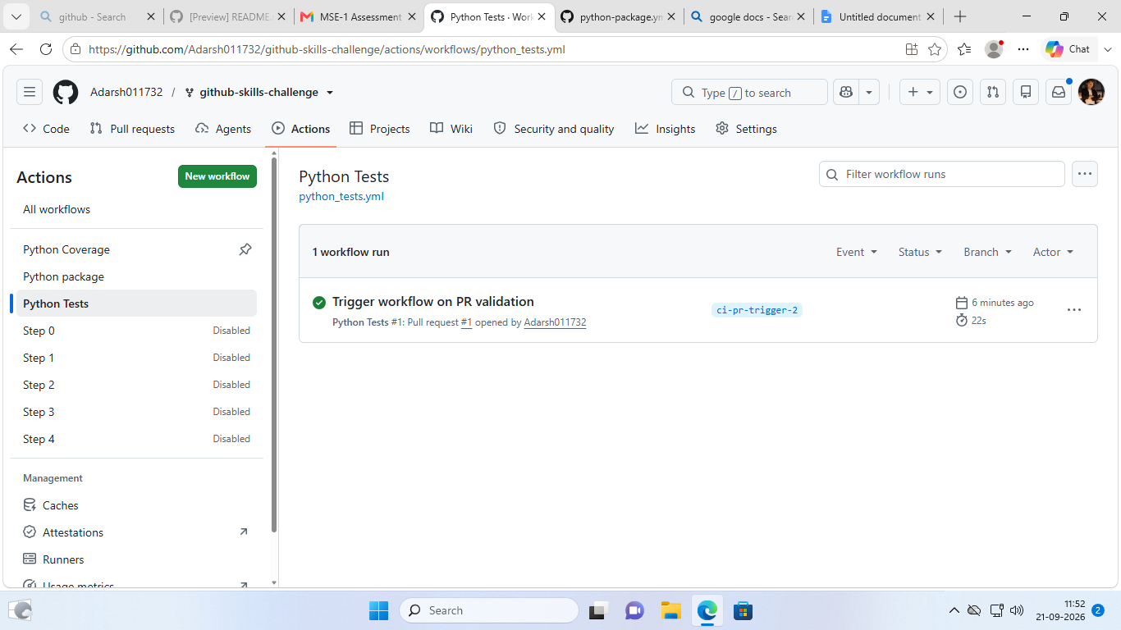
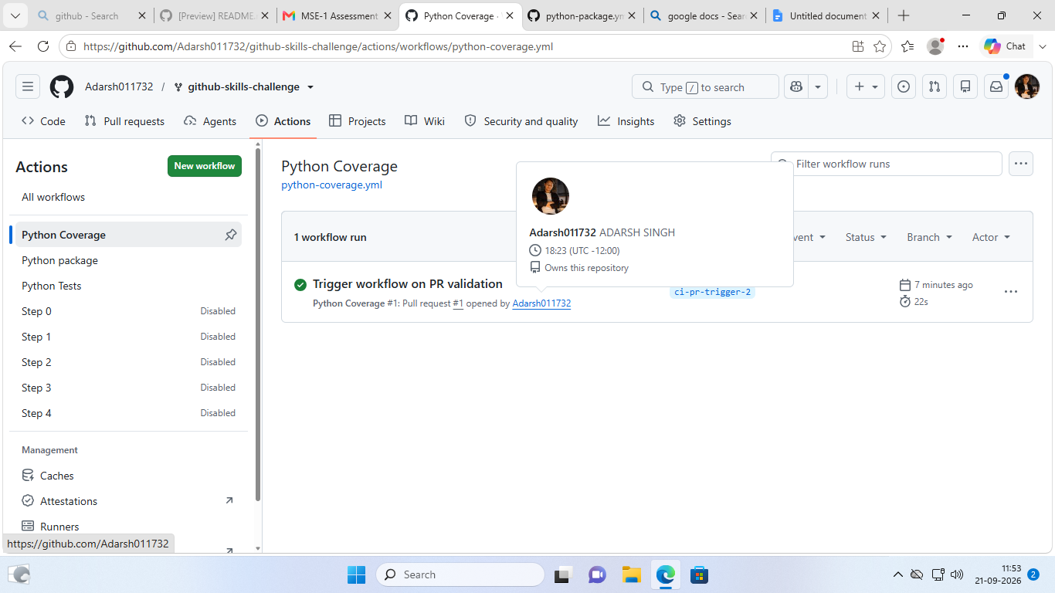

5. Screenshot showing the coverage result/comment on the pull request:
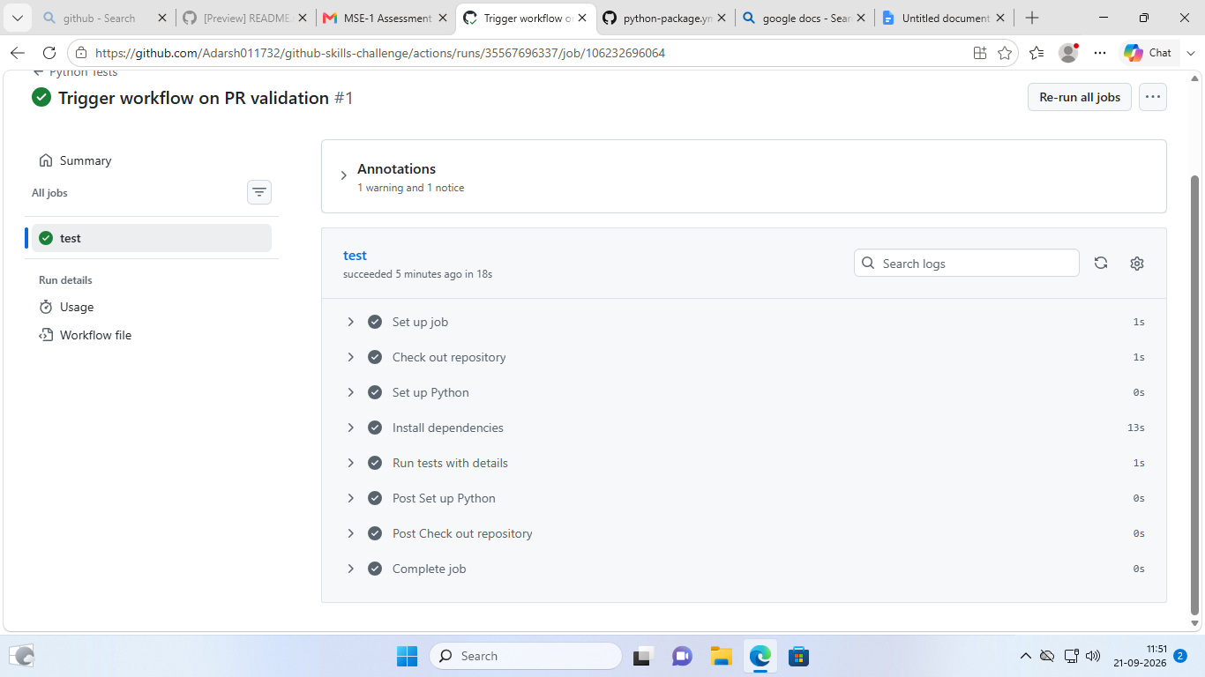
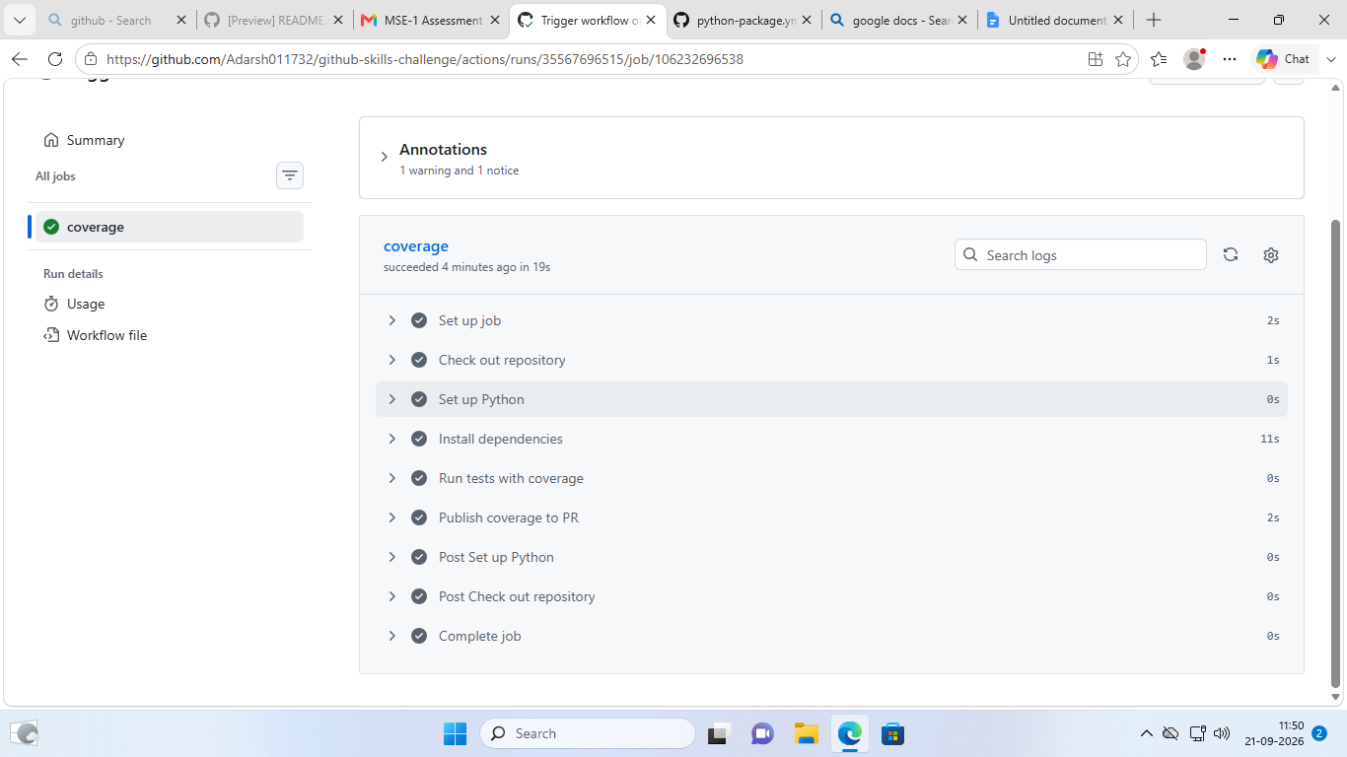

6. Screenshot showing the final repository/workflow files
